Automation of Forms to MySQL Database **and Sales Overview and Amazon dashboard in power BI**

# **The domain of the Project:**

# **SQL AND POWER BI**

# **Under the guidance of**

# **Ms. Siddhika Shah Software Engineer At HCL Technologies**

# **Prof. Radha kumari Executive Director & Founder SURE Trust**

# **By**

Mr. Mukul Suyal (Pursuing BBA)

# **Period of the project**

May 2025 to August 2025

SURE TRUST PUTTAPARTHI, ANDHRA PRADESH

**Declaration**

**The project titled “Automation of forms to MySQL DB and Amazon Dashboard and Sales Overview reports in power BI” has been mentored by Ms. Siddhika Shah, organised by SURE Trust, from May 2025 to August 2025, for the benefit of the educated unemployed rural youth for gaining hands-on experience in working on industry relevant projects that would take them closer to the prospective employer. I declare that to the best of my knowledge the members of the team mentioned below, have worked on it successfully and enhanced their practical knowledge in the domain.**

### **By: Signature**

**Mukul Suyal Mukul Suyal**

**(Pursuing BBA)**

## **Mentors: Signature**

**Ms Siddhika Shah** Software Engineer

At HCL Technologies

### Seal & Signature

Prof. Radha kumari

Executive Director & Founder   
 SURE Trust

# Table of Contents

1. DECLARATION 2
2. TABLE OF CONTENTS 3
3. EXECUTIVE SUMMARY 4
4. INTRODUCTION 6 – 7
   1. Background and Context 6
   2. Problem Statement 6
   3. Scope 7
   4. Limitations 7
   5. Innovation 7
5. PROJECT OBJECTIVES 9 – 10
   1. Project Objectives & Goals 9
   2. Expected Outcomes & Deliverables 10
6. METHODOLOGY AND RESULTS 11 – 16
   1. Methods/Technology Used 11
   2. Tools/Software Used 11
   3. Data Collection Approach 12
   4. Project Architecture 12
   5. Final Project Working Screenshots 13 – 16
   6. GitHub Link 16
7. LEARNING AND REFLECTION 17 – 18
   1. New Learnings 17
   2. Overall Experience 18
8. CONCLUSION AND FUTURE SCOPE 14 – 15
   1. Objectives and Achievements 14
   2. Future Scope 15

**Executive Summary**

This comprehensive project merges automation and analytics to enhance operational efficiency and insight generation for modern organizations. It includes the development of Power BI dashboards for Amazon sales and delivery performance, a detailed sales overview dashboard, and an integrated solution for automating Google Form responses into a MySQL database. Each solution is visually supported by step-by-step screenshots illustrating data flow, dashboard controls, and user interface interactions. The objective is not only to leverage data for actionable business decisions but also to establish robust, scalable digital processes for ongoing improvement

**Amazon Dashboard (Major Project- PowerBi)**

**Summary:**  
An interactive Power BI dashboard visualizing multi-dimensional Amazon sales data. It provides comprehensive insights into sales volume, revenue trends, product category performance, and customer demographics, with rich filtering and drill-down features supporting strategic decisions.

**Key Findings:**

* Clear seasonality and sales spikes aligned with marketing campaigns and holidays.
* Top-performing product categories dominate overall sales contribution.
* Regional sales distribution highlights key markets driving revenue.
* Dynamic filters enable detailed tracking of performance metrics by product and geography.

**Recommendations:**

* Focus marketing efforts on top-selling categories and regions showing rapid growth.
* Leverage trend insights for inventory planning and demand forecasting.
* Use customer demographic data to tailor targeted promotions and outreach.
* Expand dashboard capabilities for real-time sales tracking and alerting.

**Sales Overview Dashboard (Mini Project)**

**Summary:**  
A Power BI dashboard summarizing aggregate sales performance, customer behavior, and operational metrics. It visualizes sales trends by time, product segmentation, and geographies to support retail and operational management.

**Key Findings:**

* Certain product categories account for majority sales, suggesting concentration.
* Sales peak during specific hours and days, notably evenings and weekends.
* Customer demographics and regional breakdowns reveal market penetration.
* Variances in sales and delivery efficiency observed across locations.

**Recommendations:**

* Prioritize stocking and promotion of high-contribution products.
* Implement targeted campaigns during identified peak demand windows to maximize sales.
* Regularly monitor sales and delivery KPIs to identify and mitigate bottlenecks.
* Consider localized strategies based on regional performance data.

**Automation of Google Forms to MySQL (SQL Project)**

**Summary:**

Automated pipeline integrating Google Form submissions directly into a MySQL database, eliminating manual data entry and enabling real-time data availability for business intelligence workflows.

**Key Findings:**

* Automation drastically reduces data entry errors and latency.
* Seamless data flow from form capture to database supports accurate, timely analysis.
* Validated and structured data enhances reliability of downstream analytics.
* Demonstrated scalability potential for expanding to other data sources and systems.

**Recommendations:**

* Extend automation to additional forms and enterprise data collection processes.
* Implement robust backup and monitoring processes for sustained data integrity.
* Explore integration with cloud databases for enhanced scalability and accessibility.
* Enhance dashboard integration to support live data updates and richer analytics.

**Introduction**

**Background and Context**

The three projects showcased in the document address critical challenges in data collection, processing, and visualization using modern analytics and automation tools:

Amazon Sales Dashboard:

E-commerce platforms like Amazon generate massive transactional data across products, regions, and time periods. However, extracting actionable insights from this data is complex without effective visualization and analysis tools. The Amazon Sales Dashboard project addresses this by consolidating vast sales data into an interactive Power BI dashboard. This enables stakeholders to understand sales trends, identify top-performing products and categories, and gain customer insights. Such analytics support strategic decision-making related to inventory management, marketing efforts, and operational planning in a competitive marketplace.

Sales Overview Dashboard:

Efficient sales management requires a clear view of overall sales performance, customer purchasing patterns, and operational KPIs. The Sales Overview Dashboard project serves this need by aggregating sales data into intuitive visuals that highlight key trends such as peak sales periods, best-selling products, and revenue contributions by geography. This dashboard aids operational and marketing teams in optimizing inventory, targeting promotions, and improving service delivery based on data-driven insights, thus improving overall business efficiency.

Automation of Google Forms to MySQL Database:

Collecting form-based data manually and transferring it to databases is time-consuming and prone to error, limiting timely access to accurate data for business intelligence. This project automates the integration of Google Forms with a MySQL database, creating a seamless pipeline that captures user inputs in real time. This automation enables faster, error-free data entry, providing up-to-date data for dashboards and reports. The solution enhances data reliability and supports scalable analytics, facilitating better decision-making across various business domains.

Together, these projects demonstrate how the integration of automation with interactive analytics transforms raw data into meaningful intelligence. By applying tools like Power BI for visualization and MySQL for structured storage, they improve data accessibility, reduce operational inefficiencies, and enable proactive, informed decisions in education, retail, and data management domains.

**Goals of the Project**

**Amazon Dashboard: Build a dynamic Power BI dashboard that visualizes detailed Amazon sales data including revenue trends, product category performance, and customer demographics to help stakeholders monitor sales and make strategic decisions.**

**Sales Overview Dashboard: Develop an interactive sales dashboard in Power BI that summarizes order patterns, peak demand periods, and delivery performance, enabling operational teams to optimize inventory and delivery efficiency.**

**SQL Automation: Automate the data capture process by integrating Google Forms directly with a MySQL database, eliminating manual data entry errors and providing real-time access to clean, structured data for seamless analysis.**

**Scope and Limitations**

**Scope:**

* Automates Google Form response capture in MySQL databases for direct usability.
* Creates dynamic dashboards in Power BI to showcase Amazon and sales performance indicators.
* Integrates real-time data with executive-friendly graphical summaries.

**Limitations:**

* The analysis is only as current as the underlying datasets; delayed updates can affect dashboard reliability.
* Automation is presently limited to Google Forms and MySQL; integration across other platforms is a potential area for future expansion

**Innovation Component**

1. **Integration of Automation with Analytics:** Automating Google Form responses into MySQL creates a seamless pipeline, ensuring that data used in dashboards is up-to-date and accurate.
2. **Visualization-Driven Insights:** Power BI dashboards transform raw data into interactive visuals, making complex sales trends and customer behaviours easy to understand for non-technical stakeholders.
3. **Decision-Centric Design:** Instead of just reporting numbers, the dashboards highlight key performance indicators (KPIs) and recommendations that directly support business strategy.
4. **Scalability:** The frameworks used (Power BI + MySQL automation) can be extended to other domains such as HR, finance, or supply chain analytics.

**Project Objectives**

**1. Amazon Dashboard (Major Project)**

**Objectives:**

* Build an interactive Power BI dashboard to visualize and analyze detailed Amazon sales data.
* Track sales performance across products, categories, and regions.
* Provide insights into customer demographics and purchasing trends.
* Enable stakeholders to monitor key metrics for strategic decision-making.

**Expected Outcomes:**

* A dynamic dashboard that delivers real-time insights into Amazon sales trends and performance.
* Identification of top-selling products and revenue drivers.
* Improved ability for decision-makers to plan inventory, marketing, and resource allocation.
* Enhanced understanding of customer behavior through geographic and demographic breakdowns.

**2. Sales Overview Dashboard (Mini Project)**

**Objectives:**

* Develop a Power BI dashboard summarizing sales and financial data.
* Analyze customer ordering patterns and sales trends over time.
* Assess delivery performance across locations to identify delays and inefficiencies.

**Expected Outcomes:**

* Clear, visual insights into sales volumes, peak order times, and product popularity.
* Ability to pinpoint major contributors to delivery delays and operational bottlenecks.
* Operational visibility for restaurant managers to optimize logistics and marketing efforts.
* Data-driven recommendations to enhance customer satisfaction and increase sales.

**3. SQL Automation (Google Forms to MySQL)**

**Objectives:**

* Automate the capturing of Google Form responses into a MySQL database.
* Eliminate manual data entry errors and improve data accuracy.
* Enable real-time accessibility of structured data for analytics and reporting.
* Create a scalable and reliable automated data collection system.

**Expected Outcomes:**

* A seamless pipeline that transfers Google Form data directly into MySQL in real-time.
* Increased efficiency and reduced human error in data handling.
* Reliable, up-to-date data available for integration with Power BI dashboards and other reporting tools.
* A documented, scalable automation framework that can be expanded to other forms and data sources**.**

**Methodology and Results**

**Methods / Technology Used**

1. **Data Preparation & Analysis:**
   1. Data collected and cleaned using Excel/SQL.
   2. Data modelling performed in Power BI to establish relationships between tables (e.g., Products, Customers, Sales, Regions).
   3. DAX (Data Analysis Expressions) used to calculate KPIs (sales growth, revenue contribution, profit margins).
2. **Automation:**
   1. Google Forms integrated with Google Apps Script / third-party connector to automatically push responses into MySQL.
   2. SQL queries used for data validation, cleaning, and structuring.

**Tools / Software Used**

1. **Power BI:** For data modelling, dashboard creation, and visualization.
2. **Microsoft Excel / CSV Files:** For raw data storage and initial data cleaning.
3. **MySQL Database:** For structured storage of Google Form responses.
4. **Google Forms:** For collecting inputs directly from users.
5. **Pabbly:** For automation to integrate Pabbly with MySQL.
6. **GitHub:** For version control and hosting project files/documentation.

**Data Collection Approach**

1. **Amazon Dashboard:** Dataset obtained from structured data (CSV/Excel format).
2. **Sales Overview Dashboard:** The dataset was collected from **Kaggle**, a popular platform for high-quality public datasets.
3. **Google Forms Automation Project:** Real-time data collected via Google Forms (survey/feedback form) and stored directly into MySQL using automation pipeline.

**Project Architecture**

* 1. **Amazon Dashboard and Sales Overview Dashboard (Power BI Projects):**

1. Data Source → (CSV/Excel / MySQL)
2. Data Cleaning & Transformation → (Power Query in Power BI)
3. Data Modelling → (Relationships between sales, customers, products, and regions)
4. Visualization → (Interactive Power BI dashboards with KPIs, charts, and filters)
5. Reports & Insights → (Decision support for executives)
   1. **Automation of Google Forms to MySQL (SQL Project):**
6. User submits response via Google Form
7. Response stored in Google Sheets (default backend)
8. Data inserted into MySQL Database
9. Data validated using SQL queries
10. Connected to BI tools for analysis

**Final Project Working**

1. 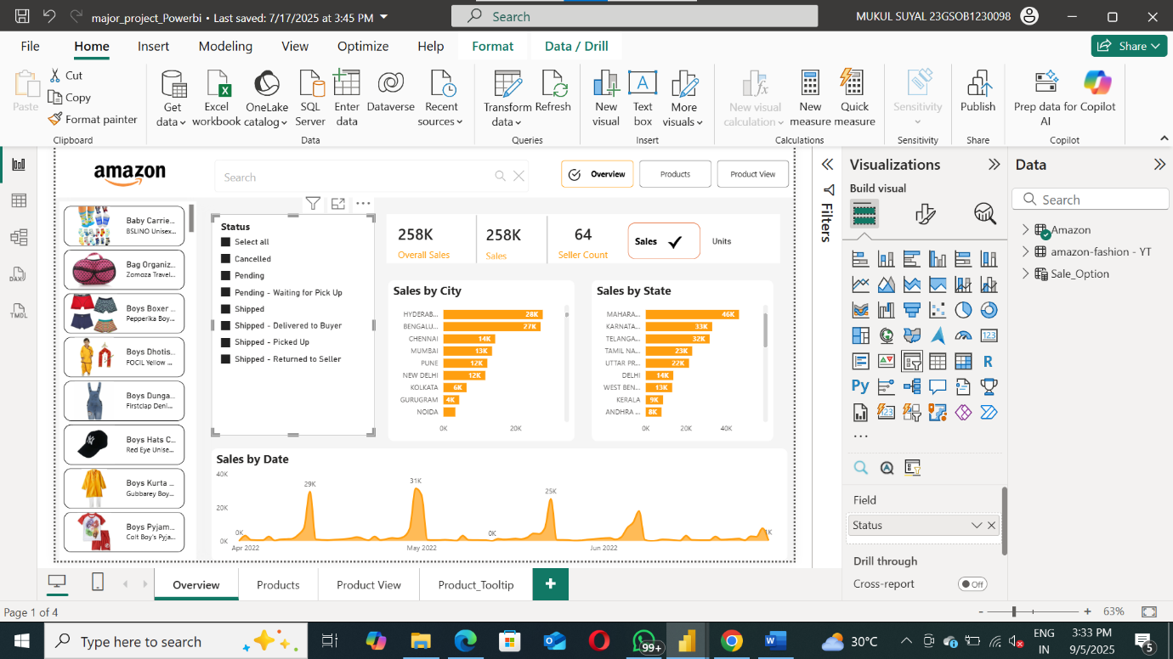**Amazon Dashboard (Major Project): -**

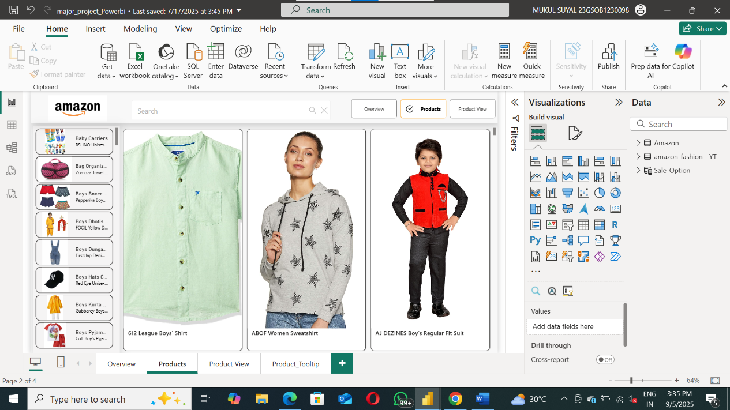**1.1:** Amazon Dashboard Page 1

**1.2:** Amazon Dashboard Page 2

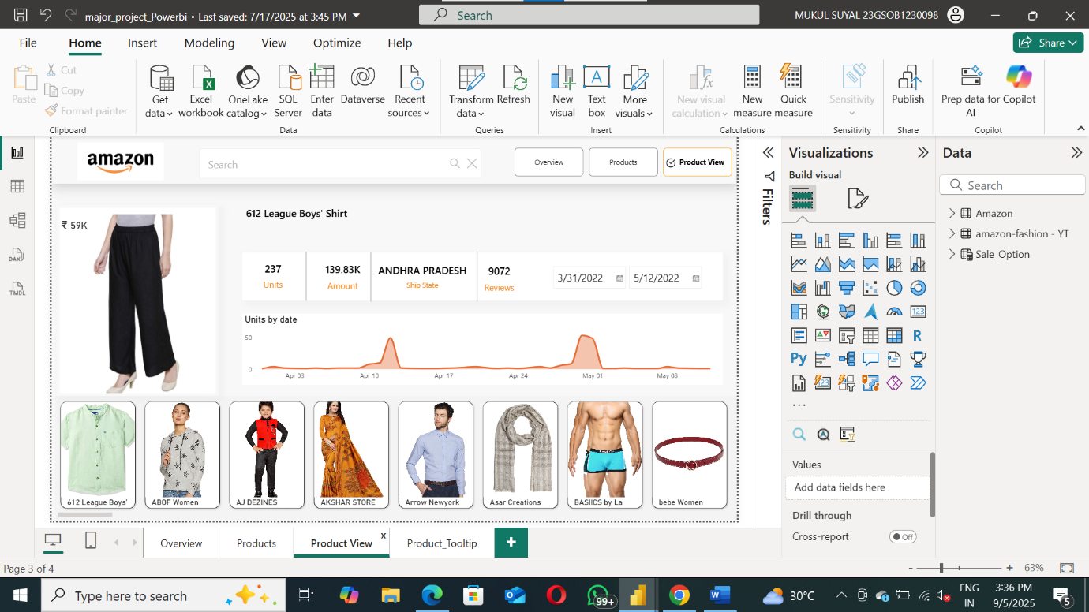

**1.3:** Amazon Dashboard Page 3

1. 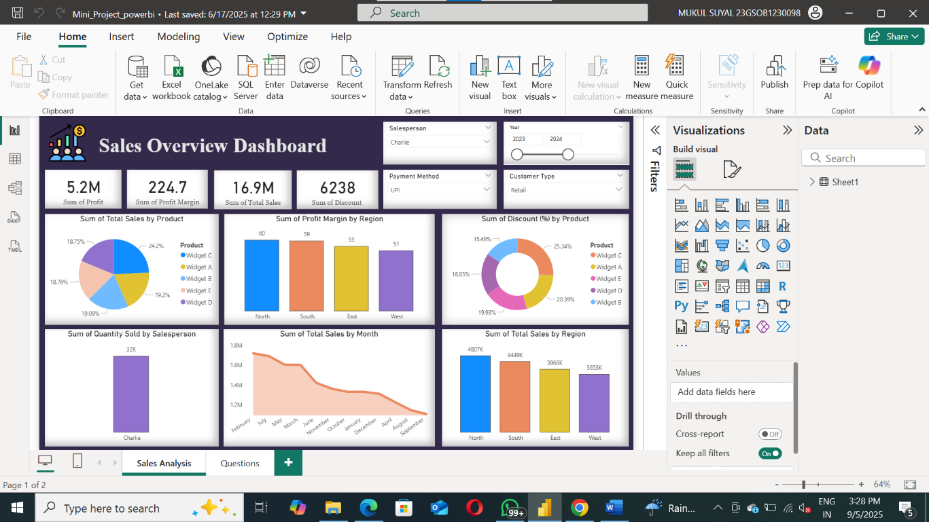 **Sales Overview Dashboard (Mini Project): -**

2.1: Sales Overview Dashboard

1. **Google Forms → MySQL Automation:**

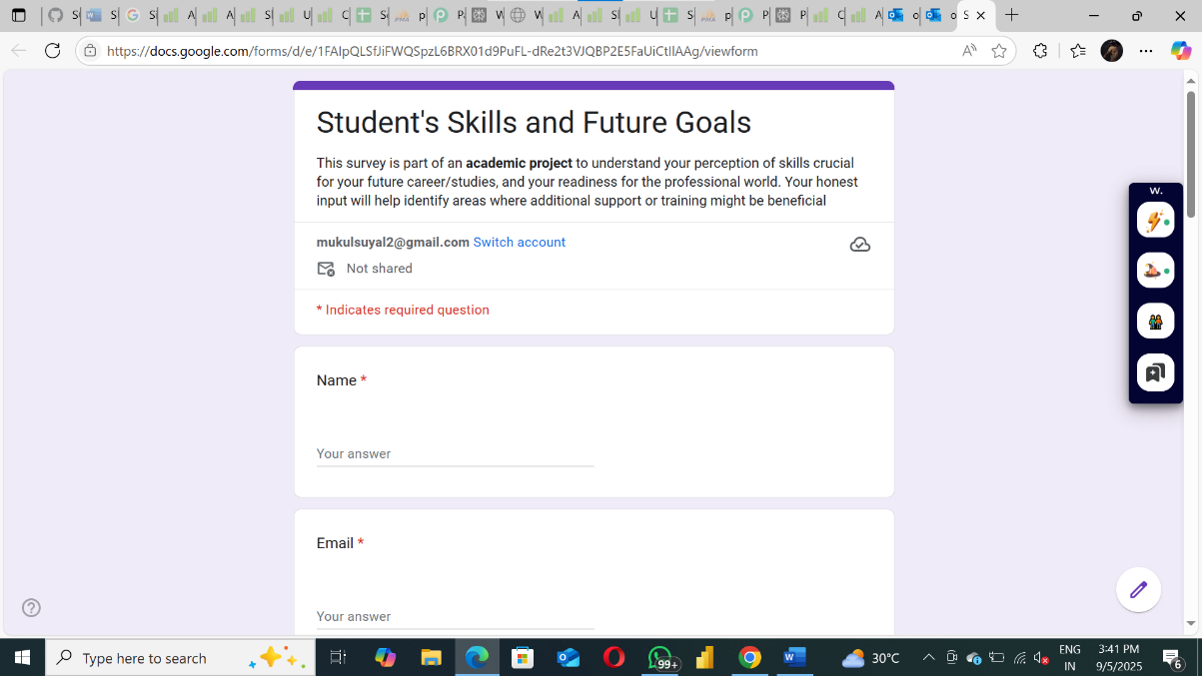

3.1: Google Form

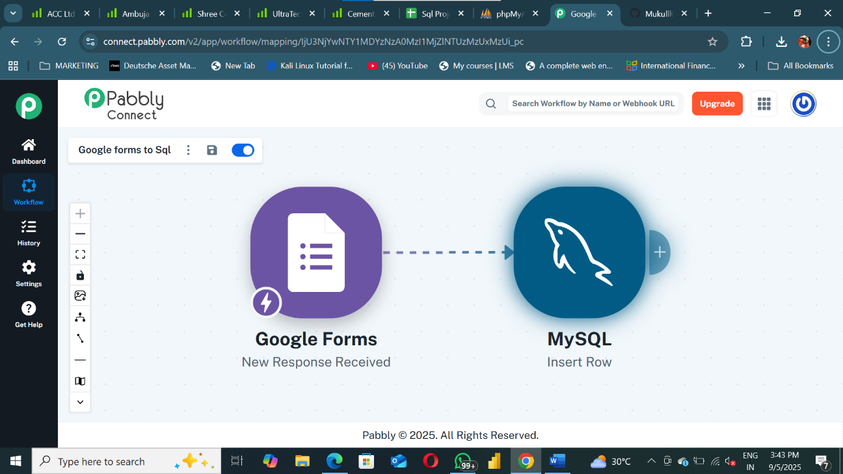

3.2: Integration of Google forms and MySQL

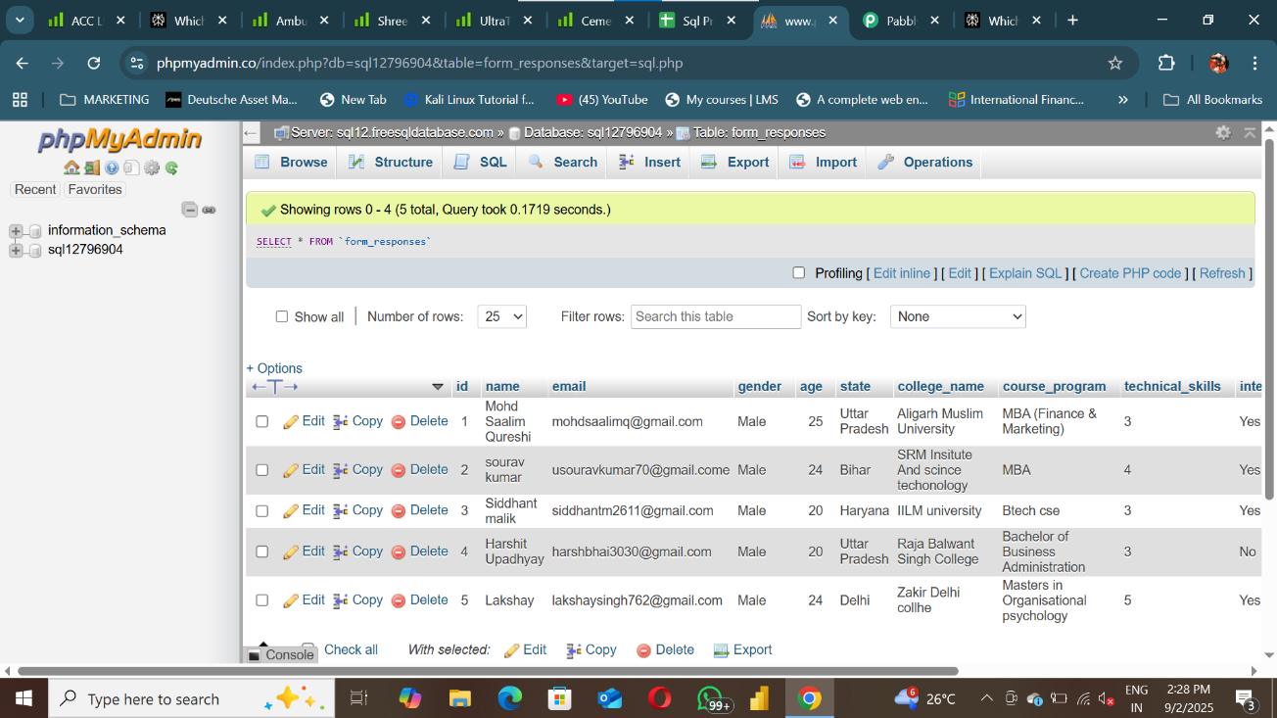

3.3: Integrated MySQL Data Base

**4. Project GitHub Link**

👉 <https://github.com/Mukulll0000/SQL-AND-POWERBI-PROJECT/tree/main>

**Learning and Reflection**

**New Learnings (Technology, Management)**

**1.Power BI & Data Visualization:**

* 1. Learned how to clean, transform, and model datasets using Power Query.
  2. Gained practical knowledge of DAX functions to create KPIs, measures, and calculated columns.
  3. Improved ability to design interactive dashboards that present insights in a clear, executive-friendly manner.

**2.Database Management (MySQL):**

* 1. Strengthened understanding of relational databases and SQL queries.
  2. Learned how to automate data entry from Google Forms into MySQL, ensuring accuracy and real-time availability.
  3. Gained experience in validating, cleaning, and structuring database records for analysis.

**3.Automation & Integration:**

* 1. Acquired knowledge of integrating external tools (Google Forms, Google Apps Script/Python) with MySQL.
  2. Learned how automation reduces manual effort and improves data consistency.

**4.Project Management & Documentation:**

* 1. Improved self-management skills by planning tasks, setting milestones, and completing the project within deadlines.
  2. Learned the importance of version control and project documentation for clarity and reproducibility.

**Overall Experience**

Working on this project as an individual gave me valuable **end-to-end exposure** to real-world data handling and business intelligence. I experienced the complete workflow

from data collection and storage to dashboard development and automation.

This project helped me bridge the gap between theoretical knowledge and practical application, particularly in:

1. **Sales Analytics** → deriving insights from raw sales data.
2. **Decision-Making Support** → creating dashboards that highlight KPIs for business strategy.
3. **Database Automation** → eliminating manual data entry through MySQL integration.

Overall, this project enhanced my technical, analytical, and problem-solving skills while also improving my ability to manage tasks independently. It has given me confidence to take on larger real-world projects involving data visualization, analytics, and automation.

**Conclusion and Future Scope**

**Conclusion**

**1. Recap of Objectives and Achievements**

The primary objectives of this project were to:

1. Build interactive sales dashboards (*Sales overview dashboard)* using **Power BI** to analyse sales trends, product performance, and customer behaviour.
2. Automate data collection from **Google Forms to MySQL** to ensure accuracy, efficiency, and real-time accessibility.

**Achievements:**

1. Successfully designed and implemented **Power BI dashboards** that provide valuable insights into sales, revenue, customer feedbacks, and sold units.
2. Developed an **automation pipeline** that transfers Google Form responses directly into MySQL, eliminating manual entry and reducing errors.
3. Delivered actionable recommendations for improving sales strategy, inventory management, and customer engagement.
4. Strengthened technical skills in **Power BI, SQL, DAX, data cleaning, and automation scripting**.

**2. Future Scope of the Project**

This project can be further enhanced and expanded in the following directions:

1. **Advanced Analytics & Forecasting:**

Implement predictive models using Python or R to forecast sales trends and customer demand.

1. **Integration with Cloud Platforms:**

Host data on cloud databases (e.g., AWS RDS, Azure SQL, Google Cloud SQL) for scalability and remote accessibility.

1. **Real-Time Dashboards:**

Connect live data sources (APIs, streaming services) to Power BI for continuous, real-time updates.

1. **Mobile-Friendly Dashboards:**

Optimize Power BI dashboards for mobile viewing so that executives can monitor KPIs on the go.

1. **Machine Learning Integration:**

Incorporate sentiment analysis (customer reviews/feedback) and recommendation systems to enhance decision-making.